MultiQC
MultiQC is the standard in bioinformatics reporting. It is used to create a single HTML report with interactive plots for multiple bioinformatics analyses across many samples. These plots can provide useful statistics about each analysis in your bioinformatics pipelines. For example, you can use it to detect outliers, anomalies, and batch effects by looking at all of the samples simultaneously.

Source: Sequera

FastQC (raw)

The first step after sequencing your biological samples is to perform quality control (QC). The purpose of quality control (QC) is to:
- Examine the reads to ensure their quality metrics adhere to our expectations for our experiment
- Identify sequencing problems and determine whether there is a need to contact the sequencing facility
- Identify over-represented contaminating sequences
- Gain insight into library complexity (rRNA contamination, duplications)
- Ensure organism is properly represented by %GC content (although sometimes this metric may be off if there is a lot of overexpressed genes)

1. Per Base Sequence Quality
Source: Harvard Chan Bioinformatics Core (HBC)
This plot provides the distribution of quality scores at each position in the read across all reads.
For Illumina sequencing, the quality of the nucleotide base calls are related to the signal intensity and purity of the fluorescent signal. Low intensity fluorescence or the presence of multiple different fluorescent signals can lead to a drop in the quality score assigned to the nucleotide. Due to the nature of sequencing-by-synthesis there are some drops in quality that can be expected, but other quality issues can be indicative of a problem at the sequencing facility.
- Instrumentation breakdown: Sequencing facilities can occasionally have issues with the sequencing instruments during a run. Any sudden drop in quality or a large percentage of low quality reads across the read could indicate a problem at the facility.
- 
- Overclustering: Sequencing facilities can overcluster the flow cells, which results in small distances between clusters and an overlap in the signals. The two clusters can be interpreted as a single cluster with mixed fluorescent signals being detected, decreasing signal purity, generating lower quality scores across the entire read.
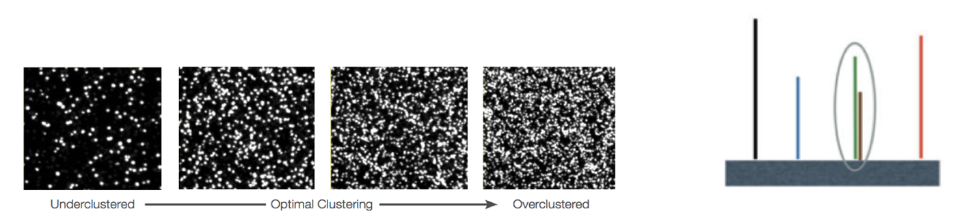

Exercise 1: Interpretation (1 pt)
Refer to the MultiQC report from your alignment run:
- (0.5 pt) What pattern do you observe in the Per Base Sequence Quality plot?
    - The Phred score per base of all runs are between 30 and 40
- (0.5 pt) What does the pattern suggest about your data?
    - The overall read quality of all seq runs is relatively good, with no over clustering and high Phred score per base

2. Per Sequence GC Content

Source: FastQC
The “Per sequence GC content” plot gives the GC distribution over all sequences. Generally is a good idea to note whether the GC content of the central peak corresponds to the expected % GC for the organism.
Over-represented sequences (sharp peaks on a normal distribution) are usually the result of a specific contaminant (adapter dimers for example). Broader peaks may represent contamination with a different species.

Exercise 2: Interpretation (1 pt)
Refer to the MultiQC report from your alignment run:
- (0.5 pt) What pattern do you observe in the the “Per sequence GC content” plot?
    - all runs generally followed same %GC curve (expected %GC curve), all had two disproportional sharp peaks
- (0.5 pt) What does the pattern suggest about your sequence data?
    - There is the presence of at least two sequences that are over-represented, most likely rRNA or miRNA contamination

3. Per base sequence content
Source: Harvard Chan Bioinformatics Core (HBC)
This plot always gives a FAIL for RNA-seq data because the first 10-12 bases result from the ‘random’ hexamer priming that occurs during RNA-seq library preparation.
Instructions: Click on a sample row to see a line plot for that dataset.

No exercise for this section.

4. Sequence Duplication Levels
Source: Harvard Chan Bioinformatics Core (HBC)
This plot helps us identify a low complexity library, which could result from too many cycles of PCR amplification or too little starting material. For RNA-seq we don’t normally do anything to address this in the analysis, but if this were a pilot experiment, we might adjust the number of PCR cycles, amount of input, or amount of sequencing for future libraries. In experiments were we expected the over-expression of certain genes, it is normal to have a large number of duplicated sequences (like the plot below).


Exercise 3: Interpretation (1 pt)
Refer to the MultiQC report from your alignment run:
- (0.5 pt) What pattern do you observe in the Sequence Duplication Levels plot?
    - All seq runs have the same trend, they all have a initial high level of duplicates that sharply drops off, followed by a spike in >10, >50, and >100
- (0.5 pt) What does the pattern suggest about your sequence data?
    - All seq runs have a large number of duplicates which is expected for RNA seq data, indicating a high level of expression in certain genes

5. Top overrepresented sequences
Source: Harvard Chan Bioinformatics Core (HBC)
The “Top overrepresented sequences” table displays the sequences (at least 20 bp) that occur in more than 0.1% of the total number of sequences. This table helps us identifying contamination, such as vector or adapter sequences. If the %GC content was off in the above module, this table can help identify the source. If not listed as a known adapter or vector, it can help to BLAST the sequence to determine the identity.

Exercise 4:
- Go to BLAST, copy and paste the nucleotide sequence of the most overrepresented sequence (from your MultiQC report) in the query.

- Select "Drosophila melanogaster" as the model organism.

- Click on "BLAST" to find matching nucleotide sequences the organism's genome.

- Read this thread (link).
- Read the extraction protocol of a sample from this experiment (link).
In the markdown cell below, answer the following questions in 1-2 sentences:
- (0.5 pt) What pattern do you notice about the matching sequences in the results?
  - Sequence doesn’t have significant match to the genome of d. melanogaster
- (0.5 pt) Explain why this nucleotide sequence is the most overrepresented sequence.
  - These reads are most likely mitochondrial transcripts and is among the most abundant in total RNA, explaining why it makes up large portion (over expressed)

